

**PSSA CLUB ADVANCEMENT GUIDELINES**

*Version 2 – updated 15th July 2023*

**Contents**

**Section 1: Introduction** ................................................................................................................................3

**Section 2: PSSA Recommended Club Advancement Guidelines**..................................................................5

2.1 Advancement levels of competency for clubs......................................................................................5

2.2 Recommended requirements for advancement in clubs ....................................................................6

2.2.1 General principles for advancement....................................................................................6

2.2.2 Time based advancement principles ...................................................................................6

2.2.3 Star Level Advancement Implementation criteria and implementation.............................7

*2.2.3.1 Advancement methodology – worked example....................................................8*

*2.2.3.2 Advancement Rules for all levels.........................................................................10*

2.3 The Award System during Assessment..............................................................................................11

2.3.1 The Sliding Scale System.....................................................................................................11

*2.3.1.1 The Assessment Process......................................................................................11*

*2.3.1.2. Guidelines for Assessment...................................................................................11*

*2.3.1.3 The Sliding Scale Conversion Table......................................................................12*

2.3.2 The Star Point System.........................................................................................................12

*2.3.2.1 The Assessment Process......................................................................................12*

*2.3.2.2 Guidelines for Assessment...................................................................................12*

*2.3.2.3 Award Assignment..............................................................................................13*

2.4 Recommended Guidelines for Joint Club Memberships………………………………………………………………..13

2.4.1 New Member’s Considerations for Joint Club Membership…..……………………………............14

2.4.2 Club Committee’s Considerations of a new member with Joint Club Membership…………14

**Annexure A**

1. Visual Representation of PSSA Proposed Sliding Scale (15 and 45 Points)…………………………………….16
2. TOP Configuration and Set-up Snapshots……………………………………………………………………………………..17

**Section 1: Introduction**

Club advancement within photography clubs affiliated to PSSA have varying rules for advancement from one star level to the next star level. Whilst there are many clubs that follow the PSSA guidelines there are some that are not aligned to PSSA advancement guidelines.

The PSSA club advancement guidelines are important primarily from a standardization perspective. For example, a 5 star in one club should be at the same level and competence as a 5 star at another club. This will also help facilitate the star rating of members who wish to join other clubs by virtue of the member’s club advancement statistics as per Photo Vault Online (PVO) system’s standard reports.

In addition to the points mentioned above, the use of the PVO system has many benefits as opposed to a unique club specific system. PSSA has standardized on PVO for use in PSSA affiliated clubs as well as for the National Salons. This goes a long way in establishing a degree of consistency amongst clubs which should be viewed in a positive light.

Therefore, the purpose of these PSSA club advancement guidelines is to standardize PSSA affiliated clubs to the same criteria that should be used to advance its members from lowest star rating to the highest star rating. For new clubs, these guidelines will provide the basis for setting up the club’s advancement criteria, associated club house rules and the configuration of the PVO and TOP systems.

These guidelines are focused on a certain number of aspects that are critical to the advancement of club members. These aspects that will be dealt with in more detail in the next section, and are noted as follows:

* Star rating levels: this is the star rating of each member in a club. Generally, all new members start off by being a 1 star moving all the way up to a 15 star (also known as a Senior Master).
* Promotion criteria: this relates to the details for advancement for each star rating level. This means that for each star rating level there are specific criteria that a member needs to achieve before they get promoted to the next star rating level. The higher up the star rating levels a member moves the higher the promotion criteria gets.
* Scoring system: this relates to the scoring system that a club adopts for its club evening judging. There are two primary scoring system that PSSA recommends but there is preference towards the 45 points system with a sliding scale. Each of these scoring systems will be discussed in detail in the next section.
* Awards: once a judge or judges have allocated their judging points for a member’s image (using either of the scoring systems), the PVO and TOP systems will have an award programmed to that score. This award is then what is announced as part of the judging process before the judge comments on the image.
* Normal photographic categories: Generally, clubs have open categories that are dealt with by the different methodologies, for example: juniors and seniors, or monochrome and colour. Each of these methodologies have different rules, so for example in the juniors and seniors, all juniors are grouped together and the seniors are grouped together and judged accordingly. With the monochrome and colour methodology, all juniors and seniors are judged together and the sliding scale scoring systems creates a level playing field whereby the judges judge the image for what it is.
* Special photography categories: Some clubs also have special categories to allow their members to get exposure into different genres of photography or get their members exposed to technical photography skills or even using different means of capturing images like with cellphones. The different genres categories can be nature, visual art, photo-journalism, portraits, sport, scapes etc. (similar to the categories used in National salons). Technical subjects could be shallow depth of field, panning, slow shutter speed, high speed sync, bokeh etc. Set subjects take on the form of specific topics like architecture, signs, trees, water, leading lines etc.
* Judging Assessment Guidelines: for the 5 point system, there is a judge’s assessment guideline which focusses on a number of important criteria that judges use to assess each photo in order to arrive at a point for the image out of 5. For the 45 point system, the same basic criteria is used by the judges in assessing the image on presentation and a score out of 15 is allocated to the image. Once the points are collated in the TOP system, an award is allocated to the score. The details of the scoring points under the different scoring systems will be discussed in more detail in the next section.

Photography clubs in South Africa have had a few scoring systems in order to promote their club members to the next level of photographic proficiency. A number of these scoring systems remain today but there are two scoring systems that are dominate in these PSSA affiliated clubs.

These scoring systems are quite different where the one system is relatively simple and the other slightly more complex. The simple scoring system is known as the 5 point system and the more complex scoring system is the 45 point system with a sliding scale.

The majority of clubs in South Africa use the 45 point system with the sliding scale as it offers members a system whereby the image is judged on its own merits and the configuration file in the TOP (The Other Project) system does the calculations based on the judge’s scores and then reflects the award of the score. This takes into consideration the members star ranking and then based on the total judges scores out of 45, allocates an award based on the sliding scale.

The 5 point system has a number range from 1 to 5. The judges scores are averaged out to give a score out of 5 or in some cases a total score out of 15. The sequencing of the images for judging is done by Juniors and then by Seniors. This allows the judges to understand the star rating of the photographer when judging their image. This means that judges look for certain criteria like exposure, composition, sharpness and impact and then “compensate” the judging points based on the star rating of the member. The system TOP system will then allocate an award based on the 5 point system.

The awards in both systems remain the same and are as follows, ranked from the highest to the lowest:

* Certificate of merit
* Gold award
* Silver award
* Bronze award, and lastly,
* No award

**Section 2: PSSA Recommended Club Advancement Guidelines**

PSSA recommends the following guidelines for club advancement which will be covered in detail.

**2.1 Advancement levels of competency for clubs – Star Rating Levels**

PSSA advocates a star rating level for each club that each club member will have a star rating. A new member with no experience of club photography will start off their photographic journey by starting off by being a 1 star. As the photographer’s competency and experience grows and they meet the next star level’s promotion criteria, they will advance to the next star level.

Initially PSSA had 10 star levels but has now incorporated a further 5 levels to ensure that the seniors continually have opportunities to progress past the Master level to the Senior Master levels. PSSA therefore has the following advancement levels for clubs:

**JUNIORS**

* 1 Star
* 2 Star
* 3 Star

**SENIORS**

* 4 Star
* 5 Star

**MASTERS**

* Master Bronze (6 Star)
* Master Silver (7 Star)
* Master Gold (8 Star)
* Master Platinum (9 Star)
* Master Diamond (10 Star)

**SENIOR MASTERS**

* Senior Master Bronze (11 Star)
* Senior Master Silver (12 Star)
* Senior Master Gold (13 Star)
* Senior Master Platinum (14 Star)
* Senior Master Diamond (15 Star)

**2.2 The recommended requirements for advancement in clubs**

In line with standardisation across PSSA affiliated clubs, the advancement requirements are based on a number of principles and guidelines in order to arrive at a generally accepted advancement methodology. These advancement requirements should also be used as a guideline for any new club.

**2.2.1 General principles for advancement**

2.2.1.1 The main principle is to base the advancement system on time and therefore by default, the accumulated points achieved throughout that timeframe will be basis for advancement. It is important to understand that the timeframe is an approximation as the skill levels of photographers are different and therefore it may take longer or shorter to get promoted to the next star level.

2.2.1.2 Points accumulated will be awarded for all possible awards on a weighted system, in addition to the requirement of a minimum number of Gold and COM awards.

2.2.1.3 In all but the entry level, advancement will be based on points acquired for club photo submissions, as well as for acceptances received in PSSA affiliated salons.

2.2.1.4 In the case of a photographer belonging to more than one club, his submissions and achievements in one club have no influence on the submissions and achievements in another club.

2.2.1.5 Where salon acceptances are required for advancement, only 3 acceptances per photo should count towards advancements. The club’s scorekeeper needs to keep track of such acceptances through the receipt of the National Salon scoresheet.

2.2.1.6 The use of international salon acceptances for club advancement is recommended especially from the senior levels.

2.2.1.7 In the master levels, it is recommended that senior members have their PSSA honours as a further requirement for promotion.

**2.2.2 Time based advancement principles**

2.2.2.1 It goes without saying, but Clubs should as a basic principle try to retain their members for as long as they can.

2.2.2.2 Clubs should expect and encourage their members to try to reach the 5-star level within a 5 year period.

2.2.2.3 The time periods are based on the time it would take an average photographer to reach the next star level. Hence the time periods are estimations which are a function of the competency and experience.

2.2.2.4 An average photographer for purposes of these advancement guidelines is defined as:

* A photographer who receives 75% Gold awards (or higher) during club assessment in his / her current star level.
* A photographer who receives at least 20% acceptances for photos entered in a national salon (where applicable).

2.2.2.5 For example, it is recommended that it should take the average beginner photographer 8 months to advance from joining the club as a 1-star photographer with no experience, to the 2-star level.

2.2.2.6 The following table shows the estimated time period for an average photographer to progress from one star ranking level to the next star rating level.

|  |  |  |  |
| --- | --- | --- | --- |
| No | **From Star Level** | **To Star Level** | **Estimated Time Period** |
| 1 | **1-Star** | 2-Star | 8 Months |
| 2 | **2-Star** | 3-Star | 10 Months |
| 3 | **3-Star** | 4-Star | 14 Months |
| 4 | **4-Star** | 5-Star | 18 Months |
| 5 | **5-Star** | Master Bronze | 18 Months |
| 6 | **Master Bronze (6-Star)** | Master Silver | 18 Months |
| 7 | **Master Silver (7-Star)** | Master Gold | 18 Months |
| 8 | **Master Gold (8-Star)** | Master Platinum | 18 Months |
| 9 | **Master Platinum (9-Star)** | Master Diamond | 18 Months |
| 10 | **Master Diamond (10-Star)** | Snr Master Bronze | 18 Months |
| 11 | **Snr Master Bronze (11-Star)** | Snr Master Silver | 24 Months |
| 12 | **Snr Master Silver (12-Star)** | Snr Master Gold | 24 Months |
| 13 | **Snr Master Gold (13-Star)** | Snr Master Platinum | 24 Months |
| 14 | **Snr Master Platinum (14-Star)** | Snr Master Diamond | 24 Months |
| 15 | **Snr Master Diamond (15-Star)** | Snr Master Infinity | n/a |

2.2.2.7 If a club prefers to change the number of photos allowed per photographer per club assessment session, **the calculation must be amended based on the above timetable**. It is suggested that such a change is discussed and approved at the Annual General Meeting (AGM) or at a Special General Meeting (SGM) of the club.

2.2.2.8 It is generally accepted that at the club assessment session (club night), a maximum number of images allowed to be entered is limited to a maximum of 4. In clubs where there are a large number of images entered per club assessment session, the club committee may reduce the number of images allowed per photographer to a maximum of 3 images, so as to manage the assessment session’s duration. In such a case the estimated time period will take longer and the club committee may reduce the number of Golds and COM’s accordingly.

**2.2.3 Star Level Advancement Criteria and Implementation**

In order for a club to implement the promotion criteria for each level, it is important to get the scoring and criteria grouped under the two scoring systems. Regardless of the scoring system, it is recommended that the following assumptions and rules are understood:

* A club will meet once per month for advancement which is called a club evening or club assessment session.
* Each member may submit a maximum of 4 photos per assessment session for advancement.
* The awards under each of the scoring systems remain the same, although the value of the awards under the two systems will be different. The awards are:
* Certificate of merit;
* Gold award;
* Silver award;
* Bronze award; and
* No award.
* The assessment process that is applied when assessing images is a three stage process, regardless of what scoring system is in place. These stages are characterized as follows:
* Each judge assesses the image and assigns a mark to it after assessing it in line with assessment characteristics (as listed below);
* The TOP system calculates the score (dependent of the scoring system) and assigns an award;
* The computer administrator announces the score and award for the image;
* A judge will then give comments, critiques and ways to improve the image.

With these assumptions and rules in mind, each of these scoring systems be discussed in some detail later in the document.

***2.2.3.1 Advancement Methodology: example from 3-Star to 4-Star level***

Based on the rules specified, there are three main criteria for advancement, being the following: (1) Golds / COMs Points; (2) Total Club Points and (3) Total Salon Points. These are computed into the TOP system in a configuration file and hence the tracking of a member’s advancement at any point is made possible.

In the first main criteria, all awards carry points as per the Points Award table under the two different scoring systems. These are all added together and tally up to the Total Club Points, being the second main criteria. However, under the first main criteria point, the minimum criteria is to achieve the number of Golds and/or COMs Points. This means that whichever comes first, the Golds/COMs points or the Total Club Points, the next criteria for advancement would be Total Salon Points, being the third main criteria. If the Total Salon points criteria is met, then the member is eligible to advance to the next level.

Next is an example of the advancement methodology that can be applied to any level based on the Advancement Criteria in the table below this example. The example assumes an ***advancement from 3-star and 4-star***.

* **Gold and/or COMs Points:**
  + 4 images per club
  + 75% of entries receive a Gold or COM award = 3 Golds and / or COMs
  + Recommended period in level (in months) = 14 months
  + Weighting of Gold award = 3 points

**FORMULA:** for a 3-star to a 4-star

(4 images x 75%) x 14 months x 3 points (for Gold award) = **126 points**

* **Silver Points:**
  + 4 images per club
  + 25% of entries receive a Silver award = 1 Silver
  + Recommended period in level (in months) = 14 months
  + Weighting of Silver award = 2 points

**FORMULA:** for 3-star to a 4-star

(4 images x 25%) x 14 months x 2 points (for Silver award) = **28 points**

* **Total Club Points:** the addition of the Golds/COMs points plus the Silver points.
  + Golds & COMs Points during period = 126 points
  + Silver points during period = 28 points
  + TOTAL Club points = 126 + 28 = **154 points**
* **Salon Points:**
  + Average number of National Salons / annum = 30 National Salons
  + Maximum number of images / National Salon can be entered = 24 images
  + Recommended period in level (in months) = 14 months
  + Period Factor (total number of images can be entered during period in level) = 14/12 = 1.2
  + Recommended Success Rate in salons = 1.74%
  + Points for National salon acceptances and awards = 1 point each

**FORMULA:** for 3-star to a 4-star

(30 National Salons x 24 images x 1.2 Period Factor) x 1.74% success rate x 1 point per acceptance / award) = **15 points**

* **Level Advancement Formula – TOP set-up**
  + Club Points - 154 points
  + **OR** Golds / COMs - 42 (count) – therefore whichever comes first.
  + **AND** Salon points - 15 points

It is vitally important that when the advancement criteria is setup in the TOP system, that specific attention is paid to these three advancement criteria. The use of “OR” and “AND” must be understood as this can affect the advancement basis of the club member.

***2.2.3.2 Advancement Rules for all levels***

The following table summarises the recommended advancement rules for all the star levels.



***Please note that it is recommended that when a member advances from the Senior level to the Master level, the member must be a member of PSSA and must have a PSSA Honour as a minimum requirement.***

**2.3 Award System during Assessment**

As mentioned in the introduction, there are currently 2 assessment systems in use in clubs in South Africa, namely the Sliding Scale System and the Star Points System. Each of these scoring systems will be discussed in detailed below.

**2.3.1 The Sliding Scale System**

PSSA recommends a system where the assessment of a photo is divorced from the award assigned for advancement. The award assignment becomes a pure calculation based on the current advancement level of the photographer. This system allows the judge / judges to assess all photos on an equal basis. It also has the advantage that the photographer has a better understanding of the real quality of the presented photo compared to all other photos, no matter the advancement level of the photographer. By way of example, a score of 10 means the same for a photograph of a 1-star photographer and a 5-star photographer – but the 10 points will not result in the same award for the 1-star and 5-star photographers due to the sliding scale award allocation.

***2.3.1.1 The Assessment Process***

Club Assessment is a three stage process as mentioned above in 2.2.3. An important set-up in the TOP system is the display settings for each image. It is recommended for the 45 Point System with a sliding scale, the following is displayed once the computer has computed the judge / judges scores:

1. Name of the image.

2. Author of the image (for gold awards and higher).

3. The total score out of 15 or 45 and the award from the sliding scale.

4. The star rating of the author.

***2.3.1.2 Guidelines for Assessment***

It is recommended that each judge scores the image out of a total of 15 points. Seeing that there are generally 3 judges, the total score will then be out of 45 points (3 judges x 15 points).

In the Sliding Scale scoring system, the judges assess the image on its own merits by paying attention to the following evaluation aspects:

1. **Exposure:** assess whether the image has been exposed correctly.
2. **Sharpness:** assess whether the image is sharp or not.
3. **Composition:** assess whether the composition of the image is done well. Elements like form, line, shape, balance, colour, light, mood etc. should be considered.
4. **Digital processing:** assess whether the digital processing of the image has been done well. Aspects like dust spot removal, saturation, contrast, colour cast, over sharpening, haphazard selective processing are to be considered.
5. **Impact:** assess whether the image has impact. This is where subjectivity comes into play and judges need to be aware of their own preferences so that this does not come in the way of prejudicing the image. Care should be taken if an image comes after a stunning image that as a judge you don’t compare this image up for assessment bearing in mind that if an image comes after

***2.3.1.3 The Sliding Scale Conversion Table***

PSSA recommends the following table of conversion as the club’s sliding scale:



**2.3.2 The Star Point System**

With the star points system, the judge needs to understand the club levels as implemented by the specific club, as well as the rules associated with each award for each level in the specific club. Typically, before each photograph is judged the photographer’s level is announced and the judge then decides on the award based on the criteria given to the judge. It is recommended that clubs that use this system prepare a briefing document that needs to be studied by the judge before judging commences.

***2.3.2.1 The Assessment Process***

Club Assessment is a three stage process as mentioned above in 2.2.3. An important set-up in the TOP system is the display settings for each image. It is recommended for the Star Point System the images arranged by star rating levels and the computer administrator announces the various start rating levels before the judging commences. On the TOP system it is recommended that the following is displayed once the computer has computed the judge / judges scores:

1. Name of the image.

2. Author of the image (for gold awards and higher).

3. The total score out of 5 or 15 and the award according to the club’s rules associated with the awards.

***2.3.2.2 Guidelines for Assessment***

The following generic guidelines are used in the star point system. The guideline is for awarding a Gold award and in the event of poor or good implementation of the guideline, a lower or higher award may be given.



***2.3.2.3 Award Assignment***

Based on the criteria given by the club for each star level, the judge needs to assign the appropriate award. The following table shows the possible awards. When more than one judge does the assessment, the TOP system will add up the scores and the computer administrator will announce the award.



*Please refer to the Sliding Tables in Annexure A for the exact scores for the Awards.*

**2.4 Recommended Guidelines for Joint Club Memberships**

For members who want to join other clubs PSSA has some recommended guidelines that will guide both the new member and club committees. The issue with a new member to a club is to establish their photographic competency and hence align the new member to an appropriate star level rating within the club without disturbing the balance within the club.

If all clubs affiliated to PSSA have more or less the same advancement methodology and rules, this process is made somewhat easier. A club should not want to place the new member at the bottom of the rung or at an level higher than the new member’s photographic competency level. This would not be deemed fair and appropriate to the new member as well as the existing members within the club. Also, there is a genuine appreciation that each club has its own uniqueness’s but as long as the different scoring systems, advancement guidelines and rules are broadly followed, the transition into an additional club should be relatively seamless.

**2.4.1 New Member’s Considerations for Joint Club Membership**

The following are the recommended guidelines for having multiple club memberships for a photographer:

1. Understanding the true reason for joining another club albeit the technical skills, creative skills or the social outings.
2. Doing your research about the club by seeking a copy of the club’s Constitution and House Rules. This would give you as a potential new member a better understanding of how well the club is constituted and operated.
3. Understanding the club’s new member application process and requirements. These requirements will be listed generally below which will assist you in preparing your application.

**2.4.2 Club Committee’s Considerations of new members with Joint Club Memberships**

Seeing that a club is generally managed by an appointed committee, the following are some of the recommendations that club committees can follow when considering new members who have Joint Memberships:

1. Call for the potential new member’s PVO Member Advancement schedule. This would only be relevant if the potential new member’s existing club’s use PVO & TOP to manage their members advancement. If this schedule is not available, the potential new member needs to produce his/her existing club advancement status statistics. This is important as this will indicate to the new club’s committee information about the potential new member , for example:
   * Current Advancement Level
   * Status within that Advancement Level
   * Number of Salon acceptances both National and International salons
2. Call for the potential new member to select a panel of 10 to 15 images that will be presented to the club’s committee for evaluation to the PVO Member Advancement schedule and the club’s House Rules for advancement. The club’s committee will then assess whether the submitted concurs with the star level rating in line with the club’s standards and levels of its existing members.
3. For many clubs in South Africa, an existing club member should or can support the potential new member’s application by briefing the committee about the new member.
4. Based on all the inputs, the club committee will determine the potential new member’s application and approve it unconditionally or with certain conditions.
5. As a main guideline the following is recommended with regards to star level rating:
   * The new potential member’s star rating can only be maximum one level lower than their current star level rating at their existing club. For example, if the potential new member is a 5 star at their existing club, the lowest level star level rating that can be allocated will be a 4 star.
   * The potential new member’s star rating cannot under any circumstances be higher than their current star level rating within their existing club. For example, the same new potential member can only be placed at a 5 star level.
   * The potential new member’s advancement scores at the new club and at the star level will commence at zero, with the exception of Salon points. The potential new member’s salon points (both for national and international salons) will carry over as they remain with the member throughout their photographic journey.
   * Despite what is contained in each club’s House Rules pertaining to Salon points, PSSA condones that any salon point earned in any club (i.e. the nominated club that each member has to entered under into PVO) can be credited into the other club’s they are affiliated to.

**ANNEXURE A**

1. **Visual Representation of PSSA Proposed Sliding Scale (15 and 45 Points)**





1. **TOP Configuration and Set-up Snap Shots**
   1. **CONFIGURATION DROP-DOWN MENU:**

This is the start-up page in the TOP system – select CONFIGURATION and a drop-down menu will appear – this si where you will config TOP to your Club’s Sliding Scale.



2.2 **AWARD SETUP**

This is where the club’s awards are loaded and configured . You must ensure that the award codes in the TOP system are correct. The award description must be written out. Under Award Type, you would select “A” for Automatic and “M” for Manual. In the case below the “M” has been selected where the computer operator will manually allocate the Best Junior and Senior award to the selected image. The last column is where you would indicate under the award type whether the author’s name will show – select “Y” for yes and “N” for no.

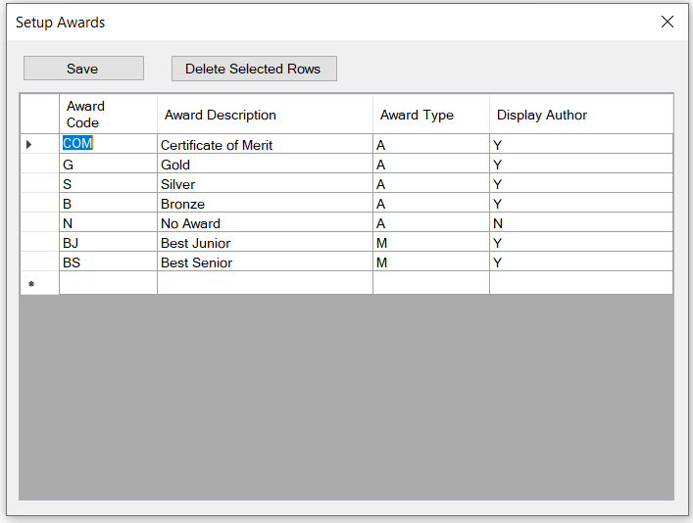

2.3 **STAR GRADING SETUP**

This is where the club’s star gradings are loaded. This is sorted from the most junior to the most senior. The last column indicates where the star grading is a senior or not. Select a “Y” if the star grading is a senior and a “N” if the star grading is under the juniors.

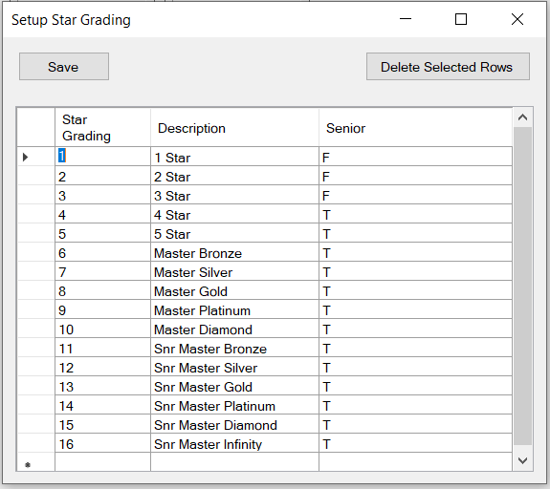

2.3 **RULES SETUP**

This is where the club’s rules as per the sliding scale are setup. This is a sample where the PSSA proposed sliding scale (45 point system) has been loaded by star grading. Please note that a greater than sign (>) includes that specific number e.g. for a 1 star – for a COM this is from 33 upwards. Please note the two areas on the left that must also be configured.

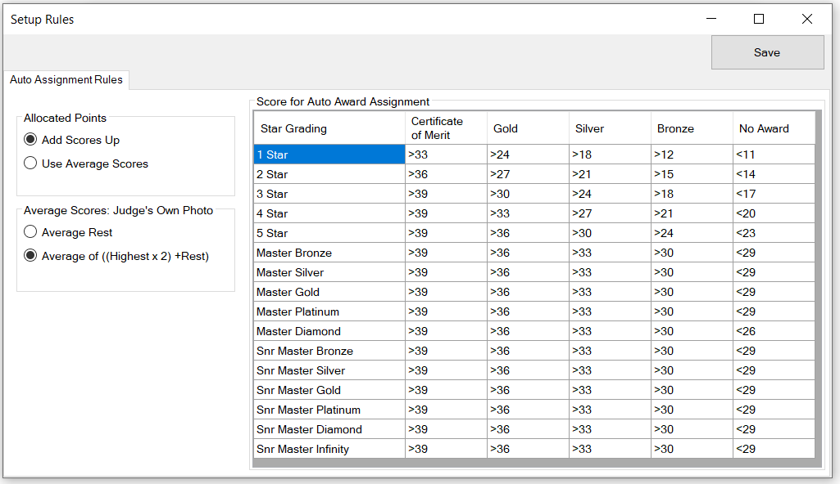

2.4 **GENERAL SETUP**

This is where the general TOP setup is done. Please explore the dropdown menus for further details. Also, this is where you would configure for 1 or 3 judges. For 1 Judge you would need to configure the Sliding Scale to the 15 point system and for 3 judges, you would use the 45 point system (15 points x 3 judges). Also please look at the configuration of the Results Display (on the bottom) – here you are able to config this to your Club’s requirement.

